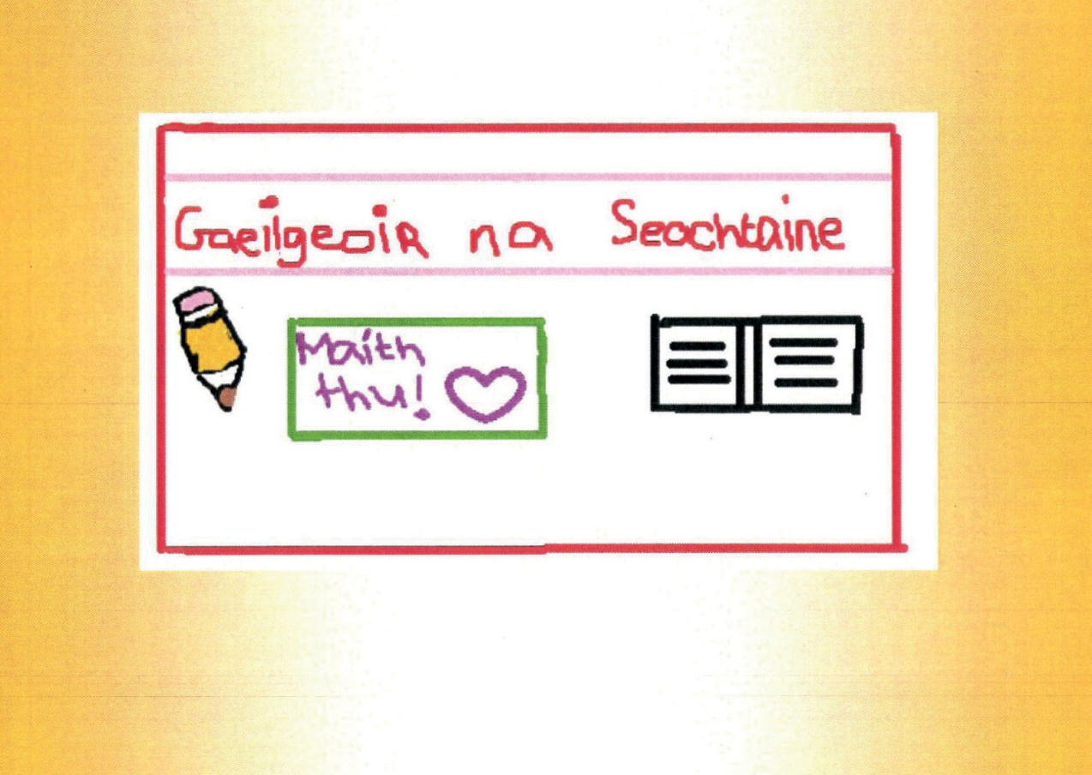



Click here and type name

Address

Address

Address

Address

Click here and type your message into this box

Chantelle Holohan

Thomond Community College

